Ideation Phase
Define the Problem Statement

Date | 02 November 2025
Team ID | NM2025TMID00562
Project Name | Laptop Request Catalog Item
Maximum Marks | 4 Marks

Brainstorming – Laptop Request Catalog Item:

This guided project demonstrates how to automate the process of requesting laptops through the ServiceNow platform.
It begins by creating a catalog item form that allows employees to submit requests with preferred configurations like laptop type, RAM, storage, and justification.
A workflow is then built in Flow Designer to route the request automatically to the requester’s manager for approval and then to the IT Support team for fulfillment.
This ensures transparency, prevents manual delays, and keeps all communication within the system.
The project also includes test scenarios to validate the process — ensuring that requests are properly created, approved, fulfilled, and closed.
The overall goal is to design a smart, simple, and efficient laptop request system that maintains accurate records while reducing unnecessary workload for IT and managers.

Step 1: Team Gathering, Collaboration, and Selecting the Problem Statement

During the brainstorming phase, the team collaborated to identify real-time challenges faced by employees when requesting hardware.
Through discussions and feedback, the team agreed on a common problem — the manual and unstructured laptop request process causes delays, confusion, and miscommunication.
Together, the team decided to develop a Laptop Request Catalog Item using ServiceNow to automate the workflow and improve employee experience.
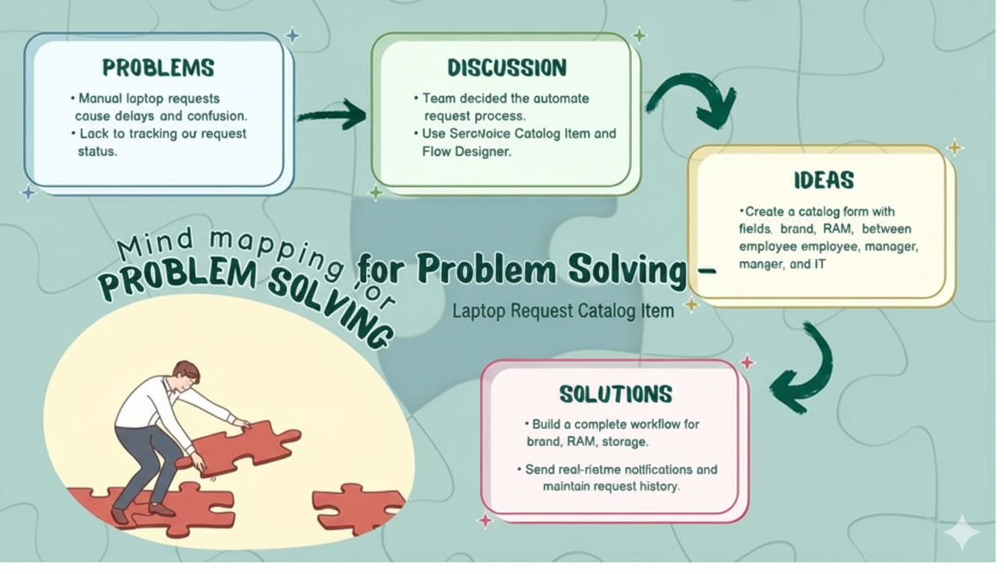

Step 2: Brainstorm, Idea Listing, and Grouping
Brainstorm:
Team members shared their ideas openly on how to make the laptop request process easier, faster, and more transparent.
Everyone contributed based on their understanding of ServiceNow’s capabilities and user pain points.
Idea Listing:
All ideas were noted to ensure no input was missed. Key suggestions included:
- Automating approvals through Flow Designer.
- Sending email notifications to the requester and manager.
- Adding dropdowns for RAM, storage, and brand to simplify selection.
- Creating a dashboard to monitor active requests.
- Generating automatic IT tasks after approval.
Grouping:
Similar ideas were combined into main categories:
- Automation: Workflow + Approvals
- User Interface: Form design and field setup
- Communication: Notifications + Status tracking
- Efficiency: Task creation + Delivery confirmation
This grouping helped in identifying which parts could be developed first and what features could be improved later.

Action Planning:
The chosen ideas were converted into clear steps:
- Design catalog form → Add necessary variables
- Configure approval flow → Test with sample requests
- Validate task creation and notifications
- Document the process and create demo video

Step 3: Idea Prioritization
Idea prioritization helped the team break down this complex process into simpler, actionable stages.
In this project, the main priority was to automate the laptop request workflow while maintaining accuracy and user satisfaction.
By prioritizing ideas, the team focused on:
- Making approvals automatic and trackable
- Ensuring requests include full laptop details before submission
- Reducing human dependency for follow-ups
- Improving communication between requester, manager, and IT staff
Visual diagrams and flowcharts were used to represent these ideas clearly.
This structured approach improved understanding and guided smooth implementation of the project.
Overall, the brainstorming and idea prioritization phases helped the team design a user-friendly, automated, and reliable laptop request system that solves real workplace problems.

